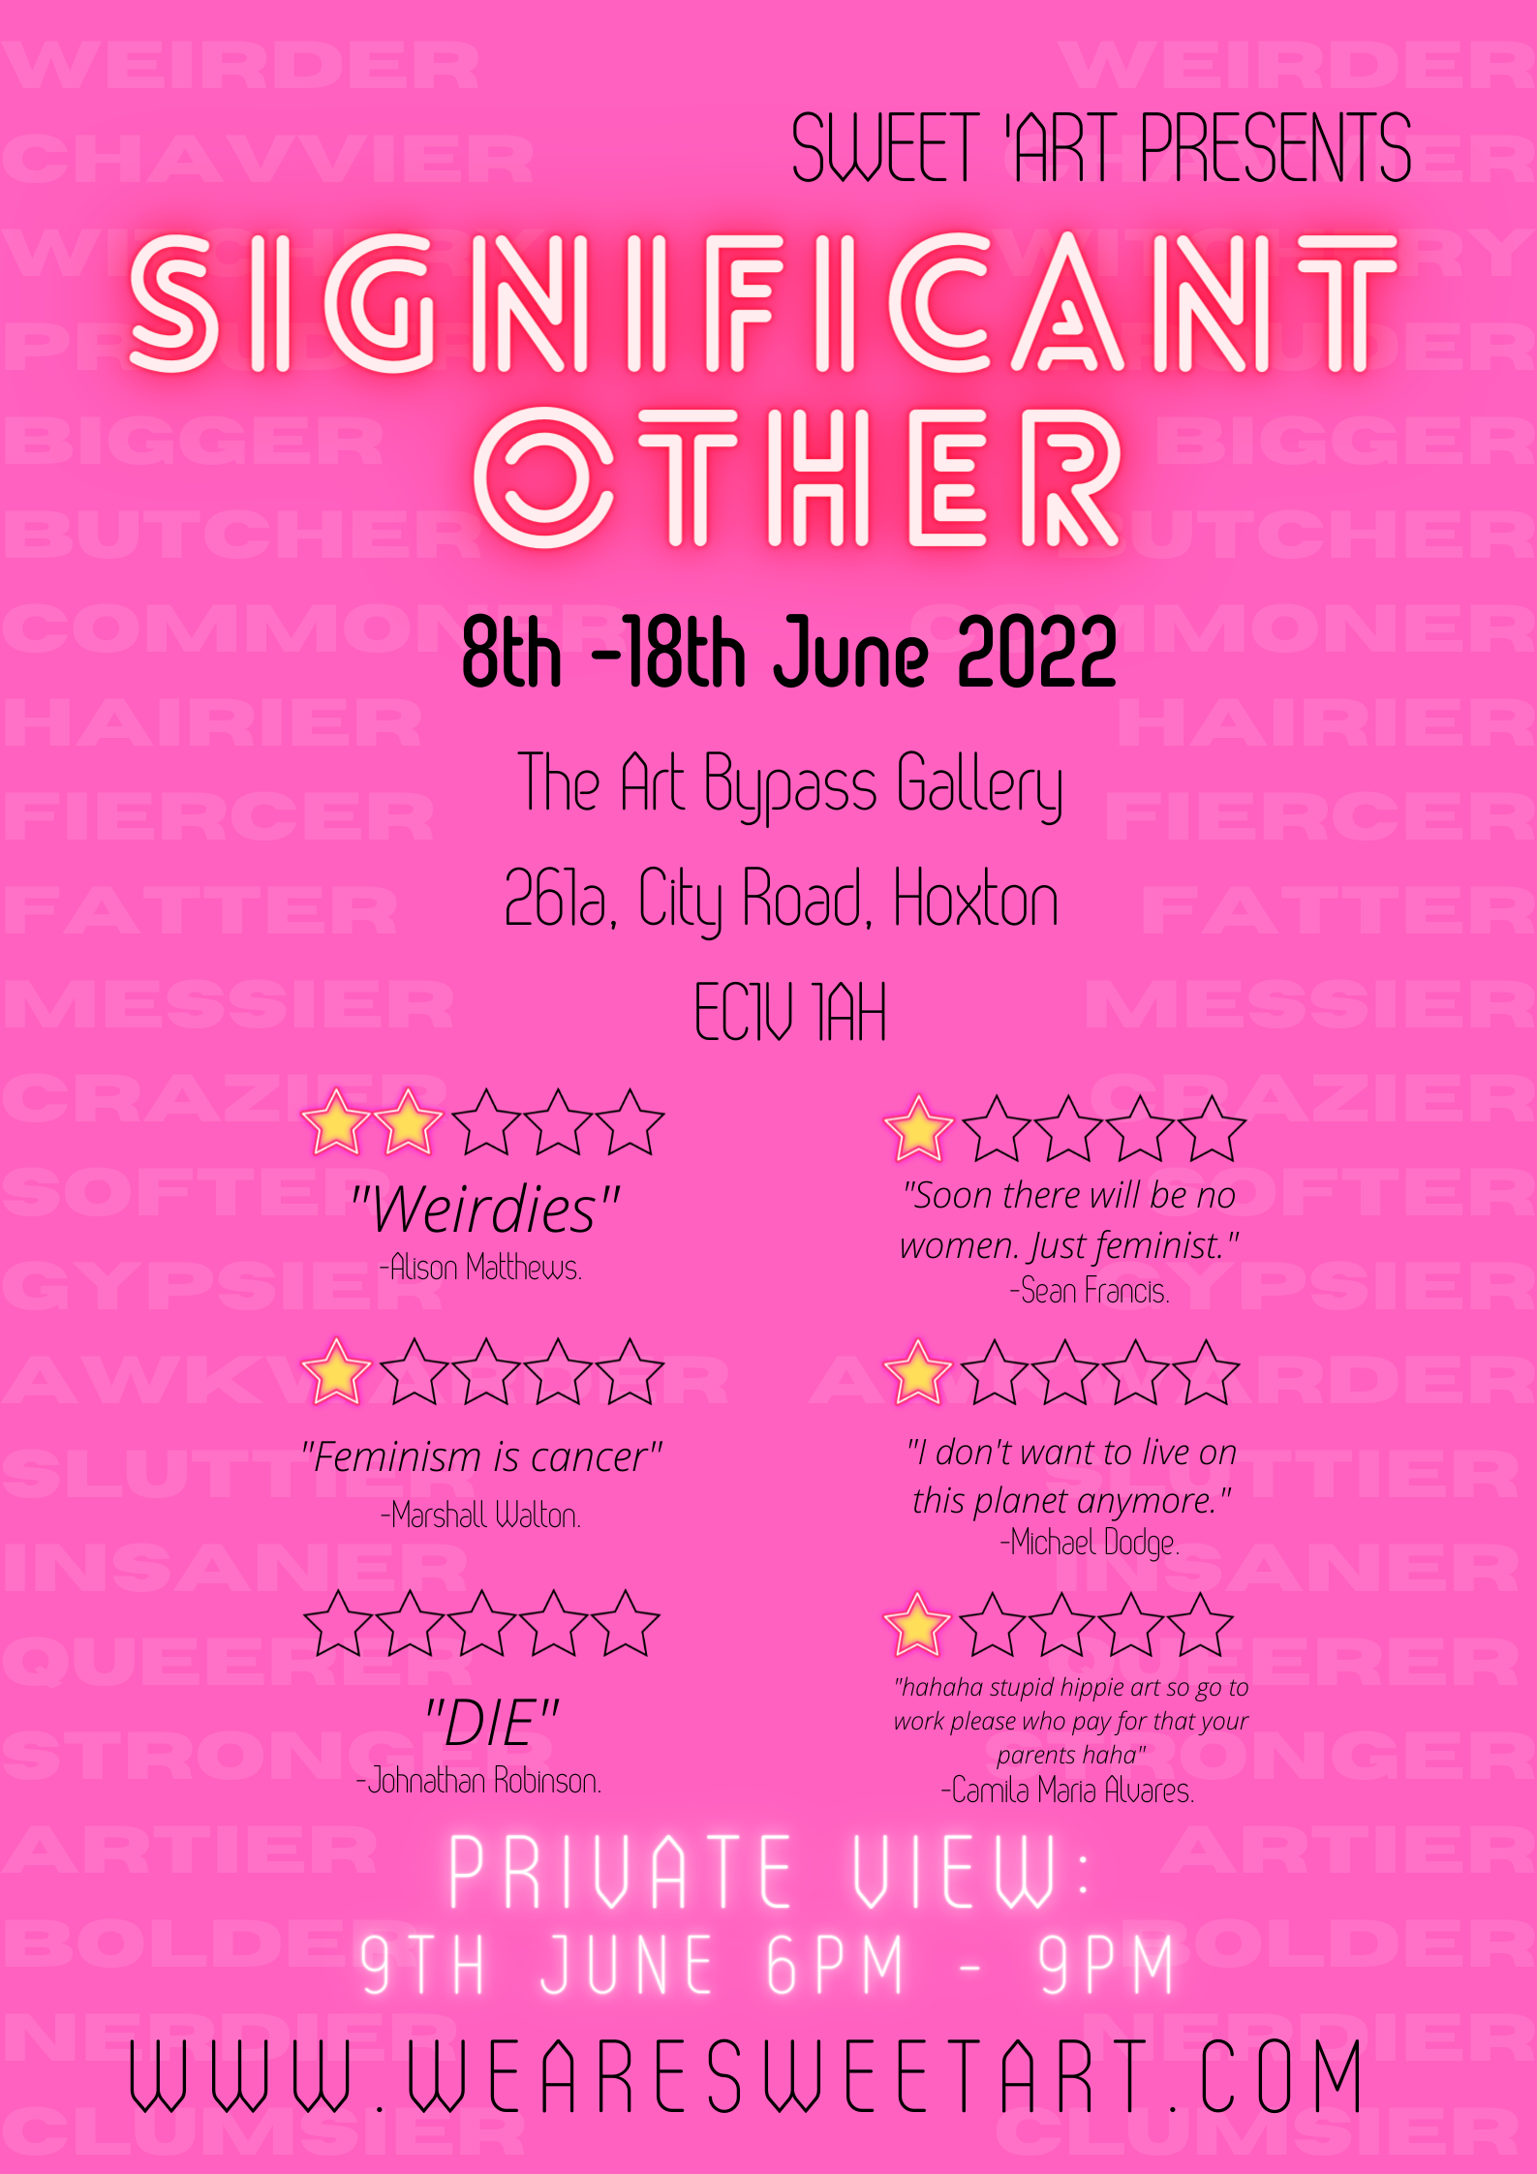

Sweet ‘Art is celebrating its 10th anniversary as an organisation this year. We wanted to look back over our 10 year achievements and try and bring together some of the amazing artists we’ve worked with over the years as well as some new artists wanting to respond to our past work. Significant Other will be a creative celebration of difference and overcoming adversity. At Sweet ‘Art our mission and values have always responded to a desire to be inclusive and provide opportunity for those who face barriers in the art world and society and may feel ‘other’; our mission being prompted in part by the Sweet ‘Art teams’ own intersecting identity related challenges, artistically and personally. This exhibition has called upon artists to respond to otherness and its richness and importance culturally, societally, personally and politically. In psychology the significant other is a person with a strong influence on an individual's self-evaluation and reception of social norms. This exhibition will respond to the importance of those that challenge societal normativity and in doing so make space for change and innovative and important practice.

Amy Wright
Belly
price on application
“That piece of toast hurt. […] Sitting up to watch my own colonoscopies was the inspiration for the text ‘Belly’. […] I don’t have access to the video footage of my own colonoscopy. Instead, I was given a lime green sheet of paper with stills from the video. These photos identify the areas of ‘hurt’. The 360-degree video provides a speculative space to engage with the text of ‘Belly’ and positions you, the audience, in the driving seat of this journey through muscular interior walls”.
“After a diagnosis of a chronic illness at 18 […] art became a way to regain control and to think critically about the network of systems that health is engulphed in.” Amy Wright reharnesses the bodily autonomy and power that one often feels stripped of during the process of becoming, or being, a ‘patient’, rejecting a vision of her body embodied by mere images of her pain for a digitally crafted, ‘POV’ video where pains and pleasures actively move through the body and, simultaneously, move the audience with them.

Celestine Thomas
Cupcake
£200
Cupcake Print
£170
“When I was a child, being dyslexic meant that colour was the language I more easily identified with, rather than ‘ABC’ or ‘123’. Colour was how I observed the world. Whilst studying Fine Art at Middlesex University, I expanded my knowledge by researching how our perception and response to colour may differ from others. My current work has taken me back to my childhood—using building blocks, collaging and pouring paint, with no limits or rules”.
Celestine Thomas’ comment on her practice as being “the art a two-year-old might make, if they had the technical skills and knowledge” is more than a quip—surfacing the ironic dismissal of ‘childishness’ and non-normative ways of seeing, thinking or acting, especially in the worlds of art and aesthetics, set against these institutions’ equal valuing of instinctive creation, liberation and freedom. Thomas’ work does not shy from and, thus, does not seek to separate childishness from these other ideas, instead proving the very real, creative value of so-called ‘childish’ modes of creation.

Chaney Manshu Diao
Bordering Tartan: the coat
£600
Chaney Manshu Diao’s practice reads identity through a lens of trans-ness. She utilises “dress, appearance, the body, linguistics and globalism” as the themes that help to channel such ideas. More specifically, In Diao’s work, the body is often something transient which sifts “in and out of geographical boundaries”, literally embodying the unfixed and uncertain states of being international; being multicultural.
“‘Bordering Tartan’ is a body of work that investigates the margins of identity. [It] zooms in on the cultural and geographical narratives around the Anglo-Scottish border”. The textile and contextual core of this collection is the black and white ‘shepherd’s plaid’ or ‘border tartan’, which Diao describes as the “signifier of this specific border heritage”. The “distribution and commodification of this design” over time, felt in her work, forefronts a lot of questions about “heritage and identity […] in relation to globalisation and capitalism”.

Corrina Eastwood
The Halfbreed Morken Keeper of Granny's Peg Knife
price on application
Corrina Eastwood’s personal and professional paths form an interconnected and expansive network: she is an artist, art psychotherapist, writer, lecturer and activist.
She offers her own text to accompany her work: “[t]he Halfbreed Morken Keeper of Granny’s Peg Knife explores the artist’s relationship with Otherness, cultural identity and trans-generational trauma, as a woman from the GRT (Gypsy Romani Traveler) community. The Morken is a hare of mixed-cultural belonging. She has mutated and adapted to be the keeper of the peg knife, passed through generations, yet she is vulnerable, hairless and exposed […]. The artist’s father believed that hares were spirits roaming the land [and] would seek revenge if you shot them. This belief protected them from being shot by him, so that was at least one less thing to worry about”.

Dan Turner
Flower/Rushnis 1, Flower/Rushnis 2, Flower/Rushnis 4, Flower/Rushnis 6
All price on application
Dan Turner is currently in residency in Thamesmead for Bow Arts. His video piece ‘Patteran’ was presented at the 50th Roma Congress Celebration Exhibition.
From his own words on his practice, Turner “looks into how human life can be archived through made objects and economic interactions […] which have significance across both cultures”, transactions, he feels, marking a meeting point between mainstream and Romani culture. From this point springs Turner’s creations, which re-work “traditional crafts and occupations such as herbalism” in the form of anthotypes—Earth’s own photographs, which leave not just no environmental marks but, eventually, no marks all together, as sunlight fades them, Turner tells. His anthotypes feel like shadows of the real thing, faded but, perhaps, more beautiful; rose-tinted, like memory.

Don McJimpsey
Where has she gone?
price on application
“Trauma is often stored in the body […] somatic sensations”.
The monochromatic, watery paint of the feminine body feels starkly more inanimate than the visceral, textured and blood-like background that appears to splatter outwards from the figure. Perhaps these inversions of the inanimateness that is associated with backgrounds and the animateness that is associated with figurative foregrounds speaks to the similar inversion trauma can conjure, between the physical hurt associated with bodily trauma and the emotional anguish associated with mental trauma. After all, psychosomatic pain is, by definition, a bodily response to damage that hits the mind first.

Ekta Bagri
Sliced up Landscape
price on application
These sculptures document what Ekta Bagri calls an ‘experiment’ on the potentiality of natural materials, such as “rocks, sand and clay deposits”, as sustainable alternatives to ceramic production. Bagri says the nature of these natural materials, in their interactions with each other during the ceramic-imitation process, allows for “controlled accidents”, taking the form of cracks, bends and scars in the kiln—a purposeful deviation from the ceramic ideal of glazed perfection. Maybe, then, from these new, sustainable ways of making art, new ways of thinking will follow. The focus of nature’s preservation in art might well shift away from the use of materials to replicate and reimagine nature in picture-perfect landscapes or decorated on pristine ceramics that use artificial, unsustainable materials and, instead, to an inverse of this idea—the sustainable use of nature as material itself; conservation through celebration.

Evelyn J
Uncertain Destination
£950
Evelyn J sets the scene of his painting as “forming a relationship against division”, divides which are clarified with the context of “a woman from a loyalist orange background […] disowned by her family for […] marrying a man from a republican Catholic background”. J acknowledges the particularly personal weight of the work, with the admission that the “specific scenario [of the scene] was the basis of my parent’s situation, meaning my knowing only one side of the family growing up”. This personal significance sinks into the style of the piece, in which J honours “the photography of Glasgow in the 1980s”; “of the Glasgow I remember”.
The jarring juxtoposition between the dark, dull, concrete-coloured tower-blocks in the backround and the flourescence of the cartoon-like characters, as well as the shops they look out onto, feels like an optimism against odds that shines through the pair, whose hands remain united against the dark divide that travels all the way up the painting via the lampost. The line this lampost forms ties together ideas of socio-political lines, geographical lines and family lines.

Freya Moffat
Untitled
£1,000
Freya Moffat refers to the carnivalesque figures of her work as ‘denizens’, offering her borrowed definition of the term: “An inhabitant, indweller or occupant of a place or region. Used of persons, animals and plants”. It is significant, then, that she simultaneously dresses and designates these figures entirely within the identity of “city commuters”, as she states. The commute often feels like it forms a kind of transitionary ‘no-place’; suspended between the spaces of ‘home’ and ‘work’ and therefore the little space and time where we belong only to ourselves, something that can fill us with both “anxiety and claustrophobia, but also [the potential for] irreverent playfulness and abandon”, a potential the commute never allows to come to fruition, given its temporary nature; our pendulum-like home-to-work; work-to-home routines. Instead, Moffat imagines ‘an alternative version of our world, at once familiar, uncanny and unsettling’, where these artificial, but none the less tangible commuter figures revel in their work-less, home-less space.

Jessica Mitchell
Pair 1: First
£250
Jessica Mitchell is “a Brooklyn-born, London-based artist, specialising in drawing and needlework”. Her work as a psychotherapist allowed her to see the “words that are spilled out of bodies […] to be considered for their meaning”. In this current series, what ‘spills out’ of the work are questions of love and how we can be “able to express it in our society, where certain connections seem to be frowned upon or actively undermined”. The drawings all share the same context: “a counter, where two friends shared many meals, and where connection, separation and disintegration all occurred”. The ripped paper and rapid-looking marks made by the oil pastels suggest a level of urgency in the work—as if what is ‘spilling out’ can’t (or shouldn’t) be plugged back up. The two sides of the canvas are separated equally by images and words; reflecting the double-edged sword of emotional expression: the insufficiency of words to verbalise what doesn’t speak, as well as, simultaneously, the insufficiency of images to visualise what can’t be seen—the climates of our “internal worlds”.

John Gathercole
Penitence Imposed (Vert)
£1,200
John Gathercole’s works have been “exhibited worldwide, including both Tate Britain and Modern”. Gathercole began his art career “as one half of the anti-art duo ‘Kuntist’”, before finding himself drawn back to his affinity for painting. He admits the influence of “the usual art bollocks” that underlines his art, offering the cliché examples of “human angst and existential struggle, probably!” as specifics.
The female body of Penitence Imposed (Vert), having always been sacrificed to surveillance, forms the shape these feelings take. The body, lying suspended in real, fleshy tones amongst a sepia-toned jury of onlookers may raise questions about whether the female figure is, very literally, rising above her audience mid-air, or is stuck; suspended, held by their gaze and its suggestions.

Kaisu Koski
Interspecies Picnic
price on application
Kaisu Koski—scientist, artist and Associate Professor of Art and Design at Lab4Living (Sheffield University) evidently emblemises the integration of art and science in both her personal life and practice: “[m]uch of my work has been developed during fellowships in various medical schools and science labs. I have created films for medical curricula on topics such as vaccine hesitancy and the breaking of bad news”. She refers to her fusing of the “climate crisis, human–non-human relationships and empathy” in her art, via collaboration with “scientists, clinicians and engineers”, as a “kind of science-fiction”.
In Interspecies Picnic, Koski’s method of merging these two opposing elements together—art and science—implements both the artistic and empirical meanings of experimentation; what she calls the “integrat[ion of] the emotional and personal […] with the scientific and theoretical”, displaying her findings on “human strategies of connecting with the non-human”.

Kinga Pilarska
Dancing with Flesh
Kinga Pilarska’s practice comprises graffiti, sculpture and painting.
Pilarska’s figures honour the form of artists’ anatomical mannequins; utilised in figurative art as guides for the connection between limbs and their combined movements and yet, in actuality, are lifeless and (literally) wooden. This allusion underlines what feels like human connection’s contradictory nature; Pilarska’s presentation of the two figures “intertwin[ing] to feel a human touch, but at a distance” encompasses the conflicts in connection, both entirely introspectively—in the simultaneous struggle and desire to connect one’s mind and body—as well as outwardly—in the comfort and discomfort relationships with others bring.

Kirstie Tebbs
How a Spider Builds her Web
£2,250
Kirstie Tebbs, founder of Tebbs Gallery, crafts pieces that surface and give shape to the intangible and tangled ideas of “absence, presence and the infinite”, as well as “the idea of being”. Tebbs finds affinity with spiders, specifically their different web weaving patterns under influence of chemical consumption (i.e., caffeine); she says of her taking Sertraline —an SSRI anti-anxiety/depressant—“I felt I was building myself differently”. With all this being said, then, Tebbs proposes a tautology between being and building; in other words, that ‘to be’ is ‘to make’, subliminally suggesting that identity is not only ever an inherent given but can be a constructable choice.

Linathi Makanda
Home as Usapho (II)
£250
Linathi Makanda, member of the Black Women Photographers global community, has had her portfolio of photographs published transnationally, most notably in Vogue Italia and ColorBloc magazine.
Home as Usapho—"with Usapho meaning ‘family’ in IsiXhosa” (one of the official languages of South Africa and Zimbabwe), Makanda informs us—forms part of her Imagining Home photographic project. This imagining is more a reimagining of “home as a person […] we orbit the photographer’s definition of home and experience the poetry of a place, a space and the liminal”. Strangely, Makanda’s shots seem to turn inward the nature of exhibited photography as a ‘looking out’ at someone else’s already-complete scene; the universally shared yet random coordinates of “a backyard, Sunday afternoon, electricity lines” and more, together, transport us to the “intersections of” our own “people, spaces and time[s]”: to (or back) home.

Marie Hego
BABADO – LA CONCHA DE TU MADRE (Princesa Kiss My Ass)
price on application
Marie Hego, born in Paris and based in Rio, “learned sculpture as an assistant in a molding studio [and] then as a restorer in Paris”. By 2018, Hego was crafting Rio’s very own carnival floats but, presently, attends to her own phenomena: her ‘BABADO’ project.
The Brazilian Portuguese word ‘babado’, conceived by Brazil’s queer community, defines “an unusual and attractive attitude, something vanguard”. Hego perceives the “animal subjectivity” of “the contemporary urban human” and channels these Carnivalesque alter-egos in her sculptures. More than mascots, these animal heads feel like iconographies; a turning inside-out of “the symbologies of nature in the collective unconscious of urban societies today”.
Mia-Jane Harris
Bloom from the Broken
£280
Having required resuscitation after being born, resulting in “the partial paralysis and stunted growth of [her] right arm” which we see represented by the broken nerves/branches of the figure’s own arm, in Mia-Jane Harris’ personal life, life and death have been drawn almost impossibly into each other’s orbits in a way that can only be described as “resurrection”-like, to use Harris’ choice of word. The unlikely and unfathomable but, nonetheless, proven possibility of proximity between these two concepts—life and death—i.e., resurrection, echoes in Harris’ thought process behind, as well as in the practical process, of her work.
“The idea […] of abnormality means a lot to me […]. I aim to intrigue the viewer […] with morbid curios to manipulate their emotions [around] mortality […]. I wish to challenge the inevitability of our disappearance after death […] [t]hrough upcycling and taxidermy […]. The animals used in my work are found naturally deceased […]. I gather my other materials from charity shops [or] dumps […]. The main items I use are porcelain figures and dolls, as these people-like figures help me to tell autobiographic tales through the work”.

Milly Aburrow
Slag Salad
price on application
Milly Aburrow’s work inspects the inextricable issues of sexuality and gender from an unconventional focal point: food. Abburow acknowledges the ‘stereotypes associated with food, embedded within our society”. She quotes an except from Philosopher G. W. F. Hegel’s 1820 book Elements of the Philosophy of Right to evidence the artificial attachment between gender and food, forced by male thinkers: “The difference between men and women is like that between animals and plants[;] [m]en correspond to animals, while women correspond to plants[,] because their development is more placid”. As a queer, female and modern artist, Abburow investigates the other neural connections current society and she herself have made, as well as those that can be made, from this main food–gender link, spanning thematic areas of consumerism, vegetarianism, queerness, Westernism and diet-culture.

Sam Hunt
Othering will Tear us Apart
price on application
Having worked as an Afrofuturist performance artist at jazz clubs as well as black theatre companies and currently working as an artist and art psychotherapist, Sam Hunt’s career has converged art, psychology, performance and identity in an array of amalgamations. Whilst studying Fine Art and Critical Theory, Hunt focalised Foucault and Fanon’s theorisations on how marginalised peoples “become scapegoats for society’s madness”, part and parcel of the process of ‘othering’.
The tale behind her series’ title: Othering will Tear us Apart transposes these ideas of the ‘othering’ process onto a linguistic framework. Hunt herself expands: With 80’s pop music as the theme—this music marking “the soundtrack to [her] first encounter with being ‘other’”—she replaces “the most important sentence modifier” of “the most memorable [80s] songs”. In language, a sentence modifier “changes, clarified, qualifies or limits” the meaning of a sentence’s surrounding words, words which would make their own sense minus the modifier. Linguistically, then, and, Hunt suggests, psycho-societally, meaning (as identity) should be self-generated and self-sufficient but it nonetheless is not, springing only from how something stands amongst others.

Wolfgang Woerner
Discarded Intimacy
£360
Wolfgang Woerner is “a mixed-media artist with a background in architecture. […] Architecture inspires ideas and points of departure. Urban life perpetually offers up the extraordinary in the everyday and is the prompt for private reflections”.
He offers this textual accompaniment to Discarded Intimacy: “[s]o many mouths wiped and so many lips touched. Words drift across tables and stories are overheard; sentences are suspended in mid-air, absorbed into the fabric and retold in fractured ways.

Yodet Gherez
Fallen Dream
price on application
Yodet Gherez currently creates short videos filmed in a format for instillation. Inspired by chanting practices shared across cultures, esotericism (subject matter “intended for or likely to be understood by only a small number of people with a specialised knowledge or interest” [Oxford]) and occultism (“involving or relating to mystical, supernatural, or magical powers, practices, or phenomena” [Oxford]) echo in her art.
In the Fallen Dream video–poem, Gherez orates her poem above and harmoniously with the instrumental indigenous chanting that loops for the length of the film. The two voices speak for the past and the present and speak together, in the way spirituality, sometimes stereotyped by Eurocentrism as other-ly in both its time and place, has presently become a thing of the ‘here and now’, not only the ‘there and then’. Perhaps spirituality’s practice of looking inwards to heal outwardly has become prevalent practice at a time when our societal, outwardly issues have spread to a scale that swamps us entirely, where the only way out is in(wards), towards the self. The camera pans in and out, meditative breath-like, onto perhaps the emblem of modern societal evil: poverty. As the camera zooms out, we are hurt by this societal issue, on a societal scale. Zooming in to the homeless man’s face, we are hurt by this personal, individual issue, on a personal, individual scale. Gherez speaks: “I love you as myself” and we are asked to do the same.

Texts written by Jessica Ross-Dreher.
Thanks to all of our contributing artists for taking part in the exhibition.
Huge thanks as well to our volunteer team: Clare McMullen, Harjoyt Kaur, Jessica Ross-Dreher, Justine-Diane Winter, Tara Ennis, Alicia Del Pino Dolz, Audrey Miao, Bella Mason, Ian Hanreck.
Sweet ‘Art are: Corrina Eastwood, Charlotte Elliston and Siân Matthews
www.wearesweetart.com

