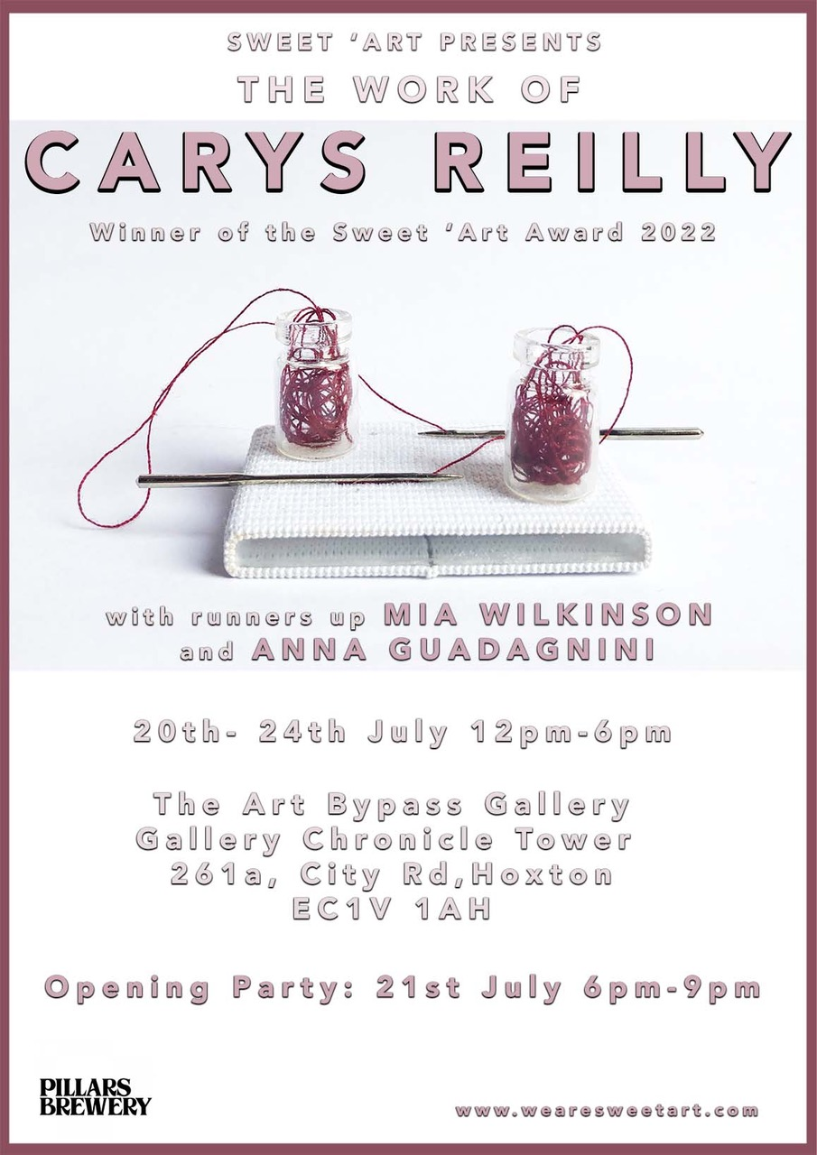

Sweet ‘Art is celebrating its 10th anniversary as an organisation this year. We wanted to look back over our 10 year achievements and try and bring together some of the amazing artists we’ve worked with over the years as well as some new artists wanting to respond to our past work.
Sweet Art’s third exhibition is a curated solo exhibition for the winner and two runners up of our art award.
In honour of our overarching mission and values we held an open entry competition for any artist exploring any medium, theme or concept in their art practice. The first prize, with the winner selected by our panel, has been selected for an exhibition in the majority of our gallery space. Two runners up have also be chosen by the panel and given the opportunity to exhibit a smaller selection of art work at the exhibition.

Award Winner: Carys Reilly
“I’ve always found humour in the pseudoscience and misinformation that forms social narratives of femininity and illness. I play with the stereotypical association of feminine-coded crafts and ‘madness’, by using labour-intensive yet poorly executed sewing and construction techniques to create absurd, ironic or untrustworthy objects. It's this aesthetic of untrustworthiness that invites the viewer to critically interrogate and ridicule the social constructs examined by my work”.
Carys Reilly’s practice implies an invitation for us to continue the long lineage of women’s art and lives throughout history: in the forceful finding of meaning in the stunting personal and societal spaces we are placed in; in the purposely purposeless. A multi-medium artist, Reilly collects these baseless coordinates of femininity (i.e., pain; the colour pink, emotional/physical breakdowns; making and fixing up) and manifests them in each drawing, painting, photograph and sculpture. All mapped out, they are exposed as visual gibberish, the recurrence of these motifs only eluding meaning even more, as we once again forced to reclaim, reinterpret and rework these anti-tools of ‘femininity’ for our own feminine experiences and identities.
Runner Up: Mia Wilkinson
Mia Wilkinson’s paintings “have found their own loopy language”, with which Wilkinson articulates the energies of her feminine forms “with intense immediacy, whilst still embracing the particularities of the female flesh”. Wilkinson’s work focalises texture; she tells how the viscous, visceral paint layers, crafted by “applying wet on wet”, “[drip] from the nipples and nails and mouth and feet” of the feminine figures until you can almost taste their grotesque sensualities. Wilkinson charges her figures with the power of “reconfiguring the male gaze”, as the exaggerated, almost geometric contours of their bodies correspondingly contour the lines and dimensions of the piece as a whole and out to the canvas itself, curvaceously contradicting the rules of and boundaries between background and foreground, as well as between subject and artist.
Runner Up: Anna Guadagnini
Anna Guadagnini’s work can be emblemised by her two photographic portfolios. Her introduction to The Other Side of Joy quotes a Premenstrual Dysphoric Disorder (PDD) web forum query: “If I am like this for two weeks a month, is that who I am?” This first portfolio welds the fragments of information and conversation surrounding women’s menstrual disorders like a tribute. Often relegated to the realms of feminine mystique, myth and exaggeration, thus left untreated, menstrual disorders and their symptoms are transposed into imagery and so too are their unshakable associations, into hyperfeminised, fairytale-like and heavily embellished motifs.
An expression of the entanglement of contradictions COVID-19 lockdowns brought us, in Back to Life, Anna Guadagnini “embrace[s] the isolation and loneliness we had all been forced to endure […] as an opportunity”. The bareness of the vacant and vast backgrounds of dilapidated structures only illuminates the vibrant, rich internal worlds Guadagnini curates for the photographs; their painfully beautiful nostalgia manifests in a confident fluorescence that feels both necessitated and emboldened by the backgrounds’ bleakness. Here, photography captures the unseen and impossible pandemic particularities of time running out and dragging on; of everything and nothingness.

About the Artists

Carys Reilly
Artist Statement
My work is shaped by my lived experience of chronic illness: I use my practice to critique social
narratives of gender roles, disability and mental health from an intersectional perspective. I examine
historical and current sensationalising of women&#39;s sadness within popular and digital culture.

My practice is cross-disciplinary, combining drawing, sculpture, photography, body art and
performance. Coming from a textiles background, the materiality of my work is chosen with great
care. My pieces are inspired by the processes involved in woven textiles: I use fabric, thread, and
repetitive imagery in minute scale in paintings and assemblages of found objects.
My current work explores how conditions including Endometriosis, Autism and ADHD are gendered,
and how my experience of them intersects with societal ideals of womanhood. I aim to find a new
visual language to portray these conditions in a way that can raise awareness of the access barriers
they cause without perpetuating misinformation or gendered stereotypes.
In particular I’m looking at how the visual representation of Endometriosis contributes to stereotypes
about the condition and alienates gender nonconforming women and LGBTQ+ patients.

Bio
Carys Reilly is a visual artist living in Glasgow. Her practice combines drawing, sculpture, painting, photography and body art. Her work is influenced by the 'Pictures Generation' artists, and the radical narcissism of 1970s feminist performance. The narratives of her practice are shaped by her own experience of chronic illness, neurodivergence, and a fascination with historical texts on hysteria.
Carys graduated from Winchester School of Art in 2015, specialising in woven textiles. Her BA collections integrated sculpture, illustration, typography and weaving to create immersive worlds and narratives critiquing contemporary attitudes towards women and mental illness.
She then went on to study at the Royal College of Art, graduating with a Masters degree in Textiles in 2017. Here she further developed her sculptural pieces and her flair for melodrama and performance, expanding on her exploration of femininity and chronic illness.
Carys has worked with several artist collectives, including Womanstanley, Outside In and Sweet ‘Art. Her piece The Hermit, The Waif, The Witch and The Queen has been exhibited in America and Vietnam, as part of an International Art Exchange with Sweet ‘Arts.
Selected Exhibitions:
9th May 2022 | Solo exhibition | SaltSpace Gallery
3rd November 2021 | "Contemporary Portraits" | Fronteer Gallery
14th October 2021 | "Bees Don't Make Lemonade" | Kitchen Gallery
9th October 2021 | "Strange Relations" | Fabrica Gallery
11th May 2020 | "Her Indoors" by Womanstanley | Online exhibition
1st September 2017 | "Sense and Sensibility" | Winchester School Of Art
14th July 2017 | "Deirdre" by Womanstanley | The Old Courts, Warrington​
2nd February 2017 | "34x34x15" | Hockney Gallery, London
10th December 2016 | "SHE Book Launch" | Unit 5 Gallery, London
11th November 2016 | "Muriel" by Womanstanley | Leeds Assembley House
30th July 2016 | "SHE", Sweet Art | Ugly Duck London
30th July 2016 | "SHE", International Exchange | America and Vietnam
13th May 2016 | "Bad Art" | Bones and Pearle Studios, London
17th March 2016 | "OTHER" | Feminist Society Exhibition at RCA, London
9th March 2016| "(NO) Body" | The Hockney Gallery, London

Website: https://www.carysreilly.com

Mia Wilkinson
Artist Statement
Through my work I create compositions of the ‘female’ body forming narratives from original collages, drawings and paint. My paintings explore proximity and entanglement embodying current emotional (and subconsciously personal) values about the female body and status in a current media culture. Despite their commodification and abjection these performers powerfully return the objectifying gaze of the viewer, with humour and powerful resilience.

Purposely provocative, blurring the boundary between actual and virtual appearance. My depictions of the female form are an exploration of this malleable line, using the joyous, exaggerated and sometimes grotesque portrayals of the female body as a method of challenging male objectification and reconfiguring the male gaze. Sometimes resembling excrement, sometimes ice cream, the deliciously repulsive bodies of the women in my paintings are sculpted by their environment and the animals or cherubic figures that surround them.

The figures I paint morph into bizarre avatars, uncertain of their identity and driven by ludicrous compulsions. Humour is a vital essence in the work; the paintings are brimming with ribald narratives, creating claustrophobic scenarios, which topple onto the space of the viewer, creating a pantomime of entangled bodies, in surreal, burlesque oppositions. There is an ambiguity of dominance and submission, jostling the norms of classical painting, from Rubens to Delacroix, to attempt to find where a contemporary female painter can belong. The work aims to seduce, as well as unmasking social absurdities and satirise gender stereotypes.
During the pandemic I challenged myself to produce a ‘drawing a day’ – unplanned and with no limitations. I scrolled through social media and drew with urgency and produced an organic collage of drawings. Using the frustrations, fear and sometimes euphoria of being trapped in a lockdown, yet also being forced to slow down - perhaps embrace the ability to enjoy the worst of the unknown. Currently I have been painting these drawings and exploring their outcome.

Bio
Mia Wilkinson b.1992
British artist, originating from the North East in County Durham and now residing in East London. Handling the paint in a fast paced vigour, Wilkinson’s paintings have found their own loopy language in which it describes the figures with intense immediacy, whilst still embracing the particularities of the female flesh. The works explore humour in the eccentricities of the human psyche expressed from a female experience and look in to cultural values around stereotypes and language.
I identify as she/her pronouns and as a cis female. I have a mixed ethnicity of Chinese and white British. I currently paint in my studio in Tottenham and live in Tower Hamlets Whitechapel.
Education: Wimbledon College of Art UAL
Group Exhibitions:
Transitional, Darlington Arts Centre, Darlington 2010, Art@51, 51 Grange Road, Durham 2011, Open, Seen, Darlington 2011, Nottinghill Mayfest, London 2012, Observing Observed, Wimbledon Project Space, London
2012, Risus Pirus, Wimbledon Project Space, London 2013, Wimbledon Degree Show 2014, Flesh, Espacio Gallery, London 2014, Seams, Sweet'art Hoxton 402 Gallery, London 2014, From Dada to Influx, Espacio Gallery, London 2015, Y-Not, Sweet'art Espacio Gallery, London 2015, The Art Takeaway Charity Auction, Sweet'art Espacio Gallery, London 2015, Hand Maid, Sweet'art Hoxton 402 Gallery, London 2016, SHE international, Tanner st, London 2016, T'ART, Bones and Pear Gallery, London 2017, The Benabai Expo, OXO Wharf Tower, London 2017, Art Alika, Clerkenwell Green, London 2017, Retrespect, The Art Bypass Gallery, London 2022, Two Doors, The House of st Barnabas, London 2022.

Website : https://www.miawilkinsonartist.com/

Anna Guandagnini
Artist Statement
“If I am like this for two weeks a month is that who I am?”
This particular sentence immediately captured my attention. I was browsing through a Google search for severe premenstrual syndrome and had just come across a condition called PMDD (pre-menstrual dysphoric disorder). I immediately recognized myself in most of the descriptions of symptoms in the little information I could find and in the words of other women going through a similar struggle.
As I began making sense of what I have been going through I felt compelled to create a body of work that would capture the fragility of these moments in a way that is also beautiful and poetic, to show that vulnerability can also be a strength, other than a cause of embarrassment and distress.
Through a series of self-portraits, conceptual still life’s and drawing directly on my personal experience, this series explores how hormonal shifts can affect women’s mental and physical health.

Bio
The work I produce is mainly portraiture. The intimate approach and autobiographical nature of my practice often result in self portraits. My photographs present a strong implied narrative, an in-between moment, a small piece of a larger story. I hope the viewer will complete the story based on their own life experience, using their imagination. The world we see is full of colours and so are my photographs, I use colour to convey emotions. I plan my images and carefully research the concepts behind the work, but when the time comes, I also want to let the creative flow lead me to the unexpected. After graduating with a BA in Fine Art at the Crawford college of Art and Design in Cork (Ireland), I moved to London where I set up a photography studio and began working as a commercial photographer while also teaching art classes and art clubs for children. I currently live and work in London.
Exhibitions:
- Upcoming 18th JMCA Exhibition October 2022 Barcelona
- 27th to 29th May 2022 ImageNation Paris
- March 2022 Light in Darkness Artdoc Magazine Online Exhibition
- New Artist Fair 01 to 03 October 2021
- Manchester 2020 Quay street exhibition October to November 2021
- April 2021 Facade: group show at the Holy Art Gallery in London.
- May 2013 Be in Rome: group show at the White Hotel in Rome.
- April 2012 Ten Artists Art Show: group show in Kinsale (Ireland)
- March 2012 Roaring 20s EYP Dublin:5 pieces exhibited at the Odessa Club in Dublin.
- March 2012 Solo show case: at Roundy in Cork (Ireland) 5 pieces exhibited.
- July 2011 C/:Forward”: degree show group exhibition , in Cork (Ireland) 8 pieces exhibited.
- March 2012 group show case: Clementina' s Art House Café in Cork (Ireland),9 pieces exhibited.
- September 2010 Transitions: group show case at Quay Co op Café in Cork (Ireland),5 pieces exhibited.
- September 2010 Art at the Office : group show at the old tax office in Cork (Ireland),8 pieces exhibited.
- June 2007 End of the year Art Show: St. John's College in Cork (Ireland) 8 pieces exhibited.

Website: https://www.annaguadagnini.com/

Texts written by Jessica Ross-Dreher or provided by the artists.
Thanks to all of our contributing artists for taking part in the exhibition.
Huge thanks as well to our volunteer team: Jessica Ross-Dreher, Justine-Diane Winter, Alicia Del Pino Dolz, Audrey Miao, Bella Mason, Ian Hanreck, Jackie Burgess.
Sweet ‘Art are: Corrina Eastwood, Charlotte Elliston and Siân Matthews
www.wearesweetart.com

